**Fundamentals of programming**

**Lab Manual 6**

***Muhammad Abdullah***

***ME-15 Section A***

***Qalam: 454502***

**Home Task:**

1. **Write a program using break or continue statement that only adds prime numbers from 1 to 50 and display the sum on screen.**

int main(){

int n,i,sum;

sum=2;

bool prime;

prime=true;

for(n=3;n<50;n++){

for (i=2;i<=n;i++)

{if (n%i==0){

prime=false;

}

}

if (prime==true)

{ sum=sum+n;

}

sum=sum+n;

}

cout<<"sum of prime numbers between 1 and 50 is"<<sum;

}

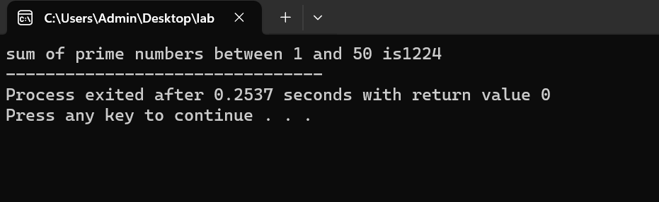

**2. Write a program in C++ to create the following pattern.**

**1**

**1 2**

**1 2 3**

**1 2 3 4**

**1 2 3 4 5**

int main(){

int line;

// Input the number of rows from the user

cout << "Enter the number of rows: ";

cin >> line;

// Nested loops to create the pattern

for (int i = 1; i <= line; ++i) {

for (int j = 1; j <= i; ++j) {

cout << j << " ";

}

cout <<endl;

}

return 0;

}

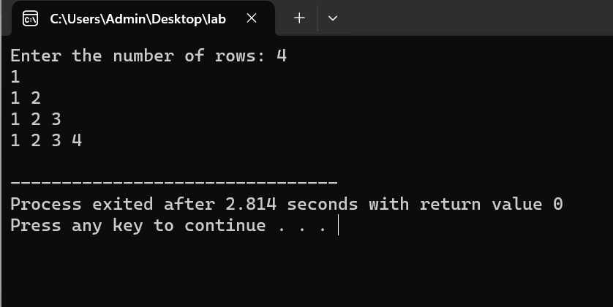

**3. Write a C++ program to print:**

**1**

**2 2**

**4 4 4 4**

**6 6 6 6 6**

int main() {

int line;

// Input the number of rows from the user

cout << "Enter the number of lines: ";

cin >>line;

// Nested loops to create the pattern

for (int i = 1; i <= line; i++) {

for (int j = 1; j <= i * 2; ++j) {

cout << i * 2 << " ";

}

cout <<endl;

}

return 0;

}

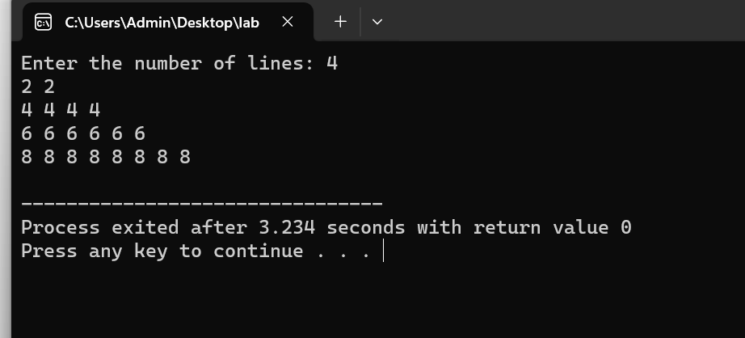

**Lab Task:**

1. **Generate the Fibonacci sequence using nested loops.**

int main() {

int num1=0, num2=1 ,num3 ,i ,n;

//asking user to enter number of elements

cout<<"Enter the number of elements: "<<endl;

cin>>n;

//outputting first two elements

cout<<num1<<" "<<num2<<" ";

//using for loop to find next elements in sequence

for(i=2;i<n;++i)

{

num3=num1+num2;

cout<<num3<<" ";

num1=num2;

num2=num3;

}

}

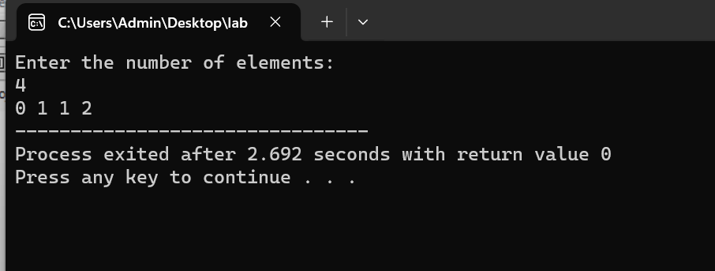

1. **Create Pascal's triangle with nested loop**

int main(){

int line;

//asking user to enter number of lines

cout << "Enter the number of lines : ";

cin >> line;

cout << endl;

//using for loop to generate sequence

for (int i = 0; i < line; i++)

{int val = 1;

for (int j = 1; j < (line - i); j++)

{cout << " ";

}

for (int k = 0; k <= i; k++)

{cout << " " << val;

val = val * (i - k) / (k + 1);

}

cout << endl << endl;

}

